Dots with AI
  - Tyler Hannan & Andrew Siegle

Summary
We will be creating an app that allows two players or 1 player plus a computer to play Dots. Dots is a multiplayer game where the players take turns drawing lines in order to connect dots and create the most boxes. The AI will vary in difficulty.
This app will be targeted toward tablet use. It will be incorporate different touch and drag controls to take full advantage of the platform. We will use a Model-View-Controller framework in Java. The app will be developed for Android 4.1.0 (Jelly Bean).

Functional Requirements
- Ability to create a new game with two use
- Ability to create a new game with one user and the computer
- Use touch and drag functionality to make a move
- Game will know when the board is complete and who has won.
- Game will keep track of running score
- Ability to reset game
- Ability to undo
- Smart AI

User Stories
- User creates a 2 player game
- User can change player names
- User creates a 1 player game against AI
- User touches screen to draw line, system draws the line and changes the current player
- User creates a square and continues to draw a line
- All squares are filled, game ends
- User undoes the previous move
- AI is able to draw a line
- AI is able to intelligently draw a line
- Completed squares are colored with the player’s color
- User can create a small game
- User can create a large game

Planning

Sprint 1

Proposed
- Setup Android XML
- Create stubs of all of the classes
- Set up android functionality to take user from home screen to creating a 2 player game (no game functionality)

Completed
- Setup Android XML
- Create Stubs of all of the classes
- Set up Android functionality to take user through screens

Sprint 2

Proposed
- Create board with varying sizes
- Respond to touches when user touches a line
- Game recognizes when the game is over and declares a winner
- Stretch – landscape layouts

Completed
- Create board with varying sizes
- Respond to touches when user touches a line
- Game recognizes when the game is over and declares a winner

Sprint 3

Proposed
- Hard AI
- Easy AI
- Undo
- Reset
- Landscape layouts
- Stretch - preferences

Completed
TBD

Figures

UML Diagram
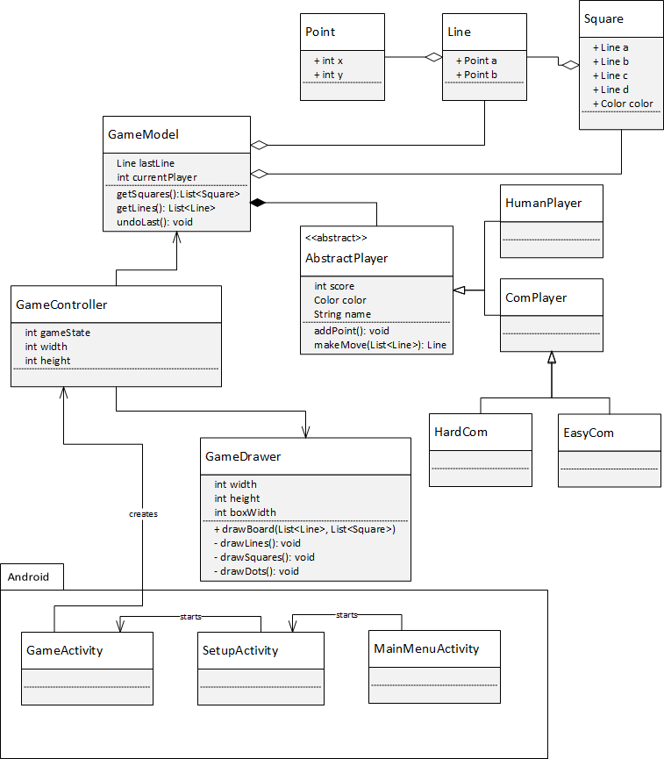

Screen layouts

